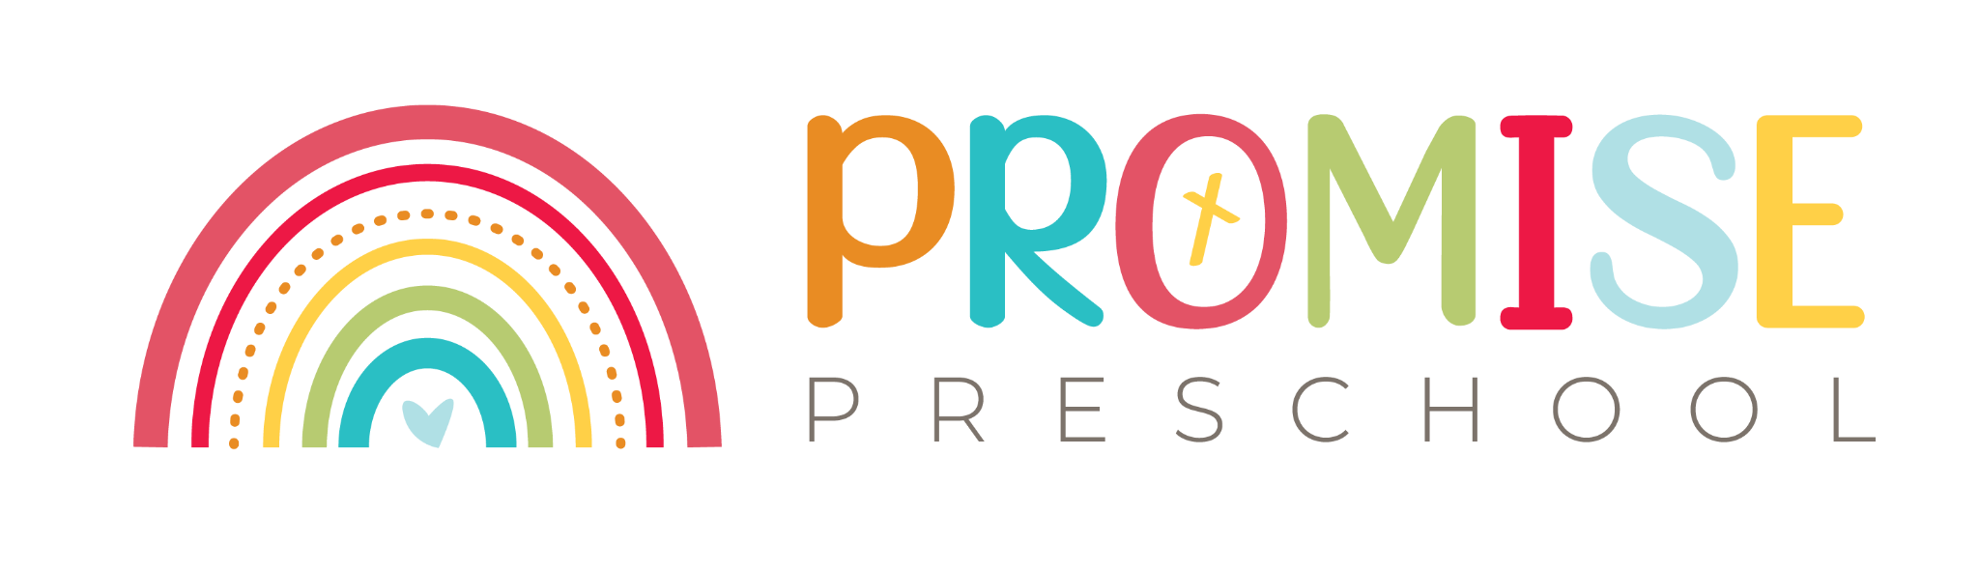

2025/26Year-Round-Calendar
August 19th /September NICE TO MEET YOU!
October 6-10th October Break (no classes this week) Fabulous FALL!
November 27-28th Thanksgiving Break (no class Thursday and Friday)
Dec.23-Jan 2nd Christmas & New Year Break (no classes) CHRIST’s Birth!
Jan 6th Classes Resume / February Celebrate Love Valentine’s day
March 9th-13th Spring Break (no classes this week) SPRING has Sprung!
April 5th Easter 20th (no classes Friday April 3rd ) – He Has Risen!
May 5th Cinco de Mayo – FIESTA Hispanic culture!
May 10th Mother’s Day – week prior make gift- All about MOTHER’S!
May 26th Graduation: class as usual ceremony at 11am
JUNE 4TH SUMMER Pool party KICK-OFF celebration
Summer Classes June & July: Letter and number review through Nursery Rhymes, Fathers Day gift making, Flag day & Fourth of July fun !
- Summer and Fall FRIDAY Field Trips dates TBD: (free and low cost tours: candy factory, fire station, police department, local library tour, local bakery tour, local pet store tour, stagedoor theater, IDEA museum, OdySea Aquarium, music museum…☺)
June 14th The American flag and pledge of Allegiance - Flag Day!
June 21ST ^{th} Celebrating Father’s Day - All about FATHERS!
July 4th Independence Day (no Friday classes) Independence Day songs and celebration July 6th and! Last summer class day August 1st Summer Vacation (Aug 3-15th no classes)
August 19th Beginning of Fall 2025/26 See Academic A-Z curriculum
FRIDAY Field Trips
(EACT day & time confirmed 2 weeks prior to date)

- August Music Museum
- October Mother Natures Farm
- January PHOENIX ZOO
- Feb. chocolate candy factory or stuffington bear factory
- March Butterfly Wonderland
- April Desert botanical garden
- May Idea Museum
- June Fire station
- July Police Department

